|  |  |  |  |
| --- | --- | --- | --- |
| **Title** | Winter is coming: Adagio - First Snow | Selfish | Teamwork |
| **Artist** | Dee-Yan Key | Derek Clegg | Scott Holmes |
| **Composer** | Dee-Yan Key | Derek Clegg | Scott Holmes |
| **Copyright** | N/A | Attribution-NonCommercial | Attribution-NonCommercial |
| **Genre** | Classical | Folk | Pop |
| **Source** | http://freemusicarchive.org | http://freemusicarchive.org | http://freemusicarchive.org |
| **File Format** | MP3 | MP3 | MP3 |
| **Number of Channels** | 2 | 2 | 2 |
| **Sample Rate (Hz)** | 44100 | 44100 | 44100 |
| **Bit Rate (kbps)** | 106 | 320 | 320 |
| **Duration** | 8 mins 13 secs | 2 mins 43 secs | 2 mins 39 secs |

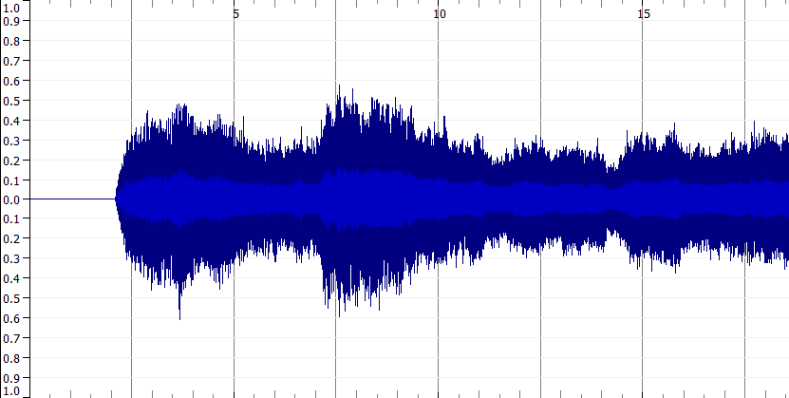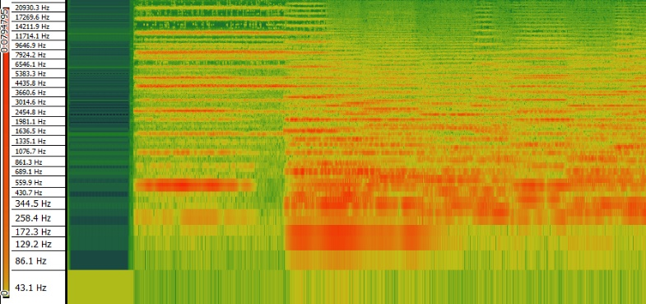When analysing music, it is possible to do both a time-frequency analysis and a waveform-based analysis. While both are able to provide analysis for the music selected, one advantage of a time-frequency analysis over a waveform-based analysis is that it can potentially provide more data than a waveform-based analysis. For example, waveforms show the volume over time for a particular signal, which, although it can be useful for analysis, it does not show more in depth data. Part of time-frequency analysis is the spectrogram, which can help show the frequencies in a signal, and show peak frequencies and pitches, and the spectrum of frequencies across time. This can be more useful when looking at more complex signals, such as music, where more data than just volume may be analysed. An example of this is in the track “Winter is Coming: Adagio – First Snow” by Dee-Yan Key. The waveform shows that at 10 seconds in, the volume level hits about 0.3Db, which is useful data to know, but the spectrogram can help show what the peak frequencies and most frequent pitches are at different times.